Functional Requirements:

* TAFR01:

The app should be able to fine the location of:

* + Hotels
  + Famous Restaurants
  + Museums
  + Shopping malls
  + Hospitals
  + Bars Pubs or Clubs
  + Movies and Theatrical Shows

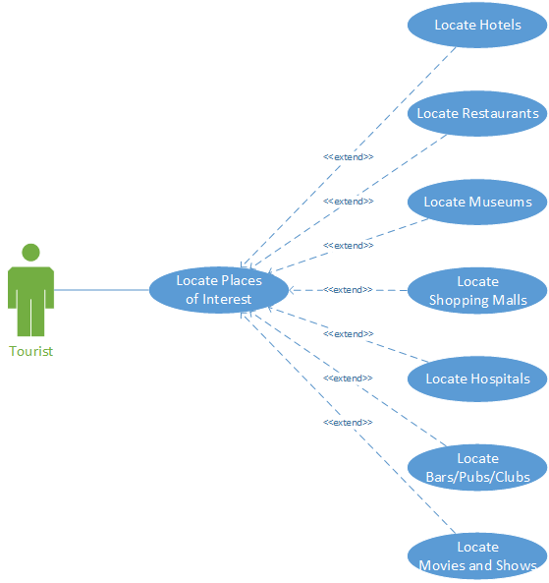

* TAFR02:

It should be able to list current events.

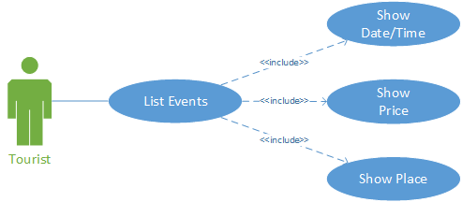

* TAFR03:

Show transit points

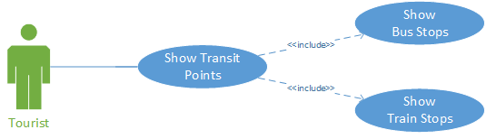

* TAFR04:

App should behave in a way such that we are able to find the location and pin point the coordinates accordingly.

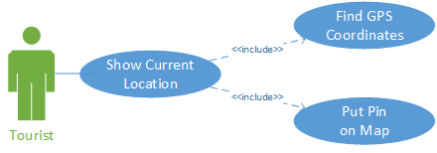

* TAFR05:

Search functionality that allows to filter the places by price, category, rating and popularity.

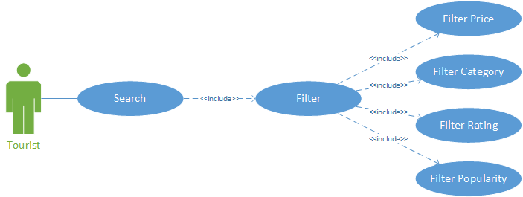

* TAFR06:

Social network connection that the user may use to share his experience.

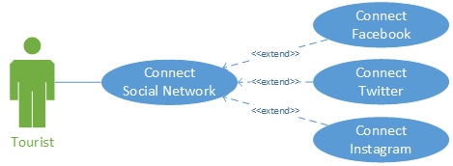

* TAFR07:

The app should support multiple languages: English, French and Spanish.

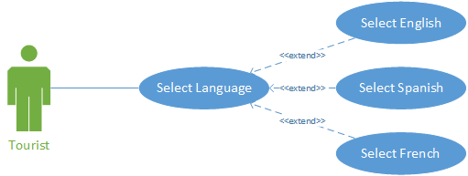

* TAFR08:

The app should memorize which places have been already visited by the user.



* TAFR09:

The app should allow the user to write reviews and rate the places that have been visited.

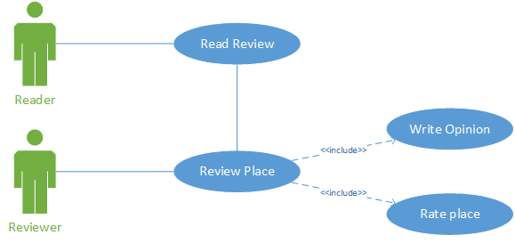

Non-Functional Requeriments

* TANFR01:

The application user interface should be designed either by bootstrap or any other available sources

* TANFR02:

The overall architecture that we are going to Follow i.e, Host server APIs, Database, UI server and design.